## A comprehensive yet easy-to-read resource written for endurance athletes by an endurance athlete!

## Suzanne Girard Eberle, a former elite athlete (4:28 mile/32:40 10K, USAT&F 5,000-meter track champion and member of 3 USA teams), is a sports dietitian who practices what she teaches!

# ***Endurance Sports Nutrition***

**-Third Edition**

**By Suzanne Girard Eberle, MS, RDN, CSSD**

### Eat, Drink, Win!®

Web: [www.eatdrinkwin.com](http://www.eatdrinkwin.com)

Phone: 503.223.5243, #2

Email: suzanne@eatdrinkwin.com

Up-to-date, practical and effective advice endurance athletes want:

**Part I: Nutrition Strategies for Endurance Athletes  
Chapter 1:** Eating Smart, Training Smart, Racing Smart  
**Chapter 2:** Meeting Energy Demands  
**Chapter 3:** Weighty Matters: Losing, Gaining, and Maintaining  
**Chapter 4:** Timing Fuel and Fluids for Optimal Results  
**Chapter 5:** Using Supplements Effectively  
**Chapter 6:** Solving Peak Performance Challenges  
**Chapter 7:** Endurance Eating for Vegetarians  
**Chapter 8:** Meal Planning for Endurance Athletes

**Part II: Nutrition Plans for Specific Events and Conditions  
Chapter 9:** Shorter-Range Endurance Events  **Chapter 10:** Long-Distance Endurance Events  **Chapter 11:** Ultraendurance Events **Chapter 12** Multiday and Multileg Endurance Events  
**Chapter 13:** Rowing and Open Water Swimming **Chapter 14:** Extreme Heat **Chapter 15:** Extreme Cold  
**Chapter 16:** High Altitude

**Yes!** Please send me ______ copy(ies) of ***Endurance Sports Nutrition-  
 Third Edition*** @ $23.95 each. Add $3.00 shipping for the first book and   
 $2.00 for each additional book. (Note: rates for US addresses only.)

Name of intended recipient (for personal message) ________________

Ship to ____________________________________________________

Street address ______________________________________________

City ____________________State__________Zip__________________

Phone _____________________Email ___________________________

Send completed form and a check (payable to Suzanne Girard Eberle) to:  
 2423 SW Montgomery Drive, Portland, OR 97201

Make checks payable to: Suzanne Girard Eberle

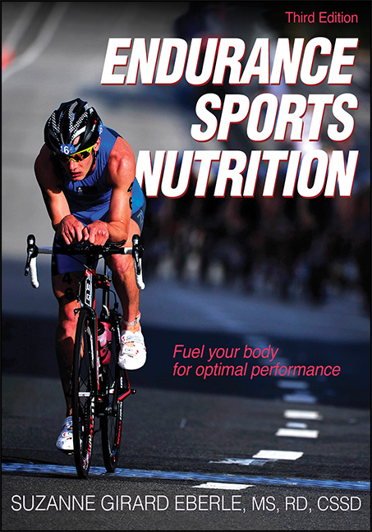

Your business tag line here.